ANGULAR HANDS ON 2

Home.html
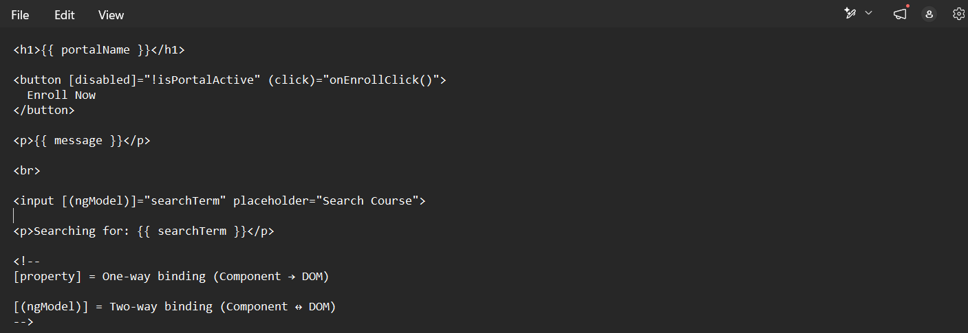

Home.ts
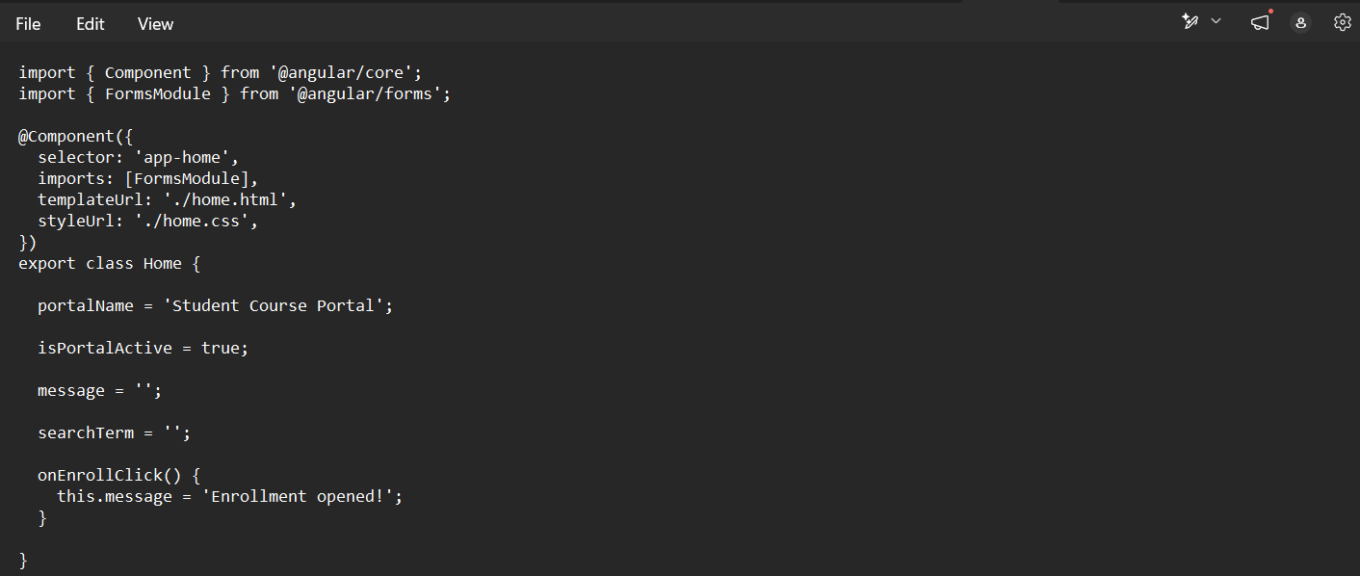

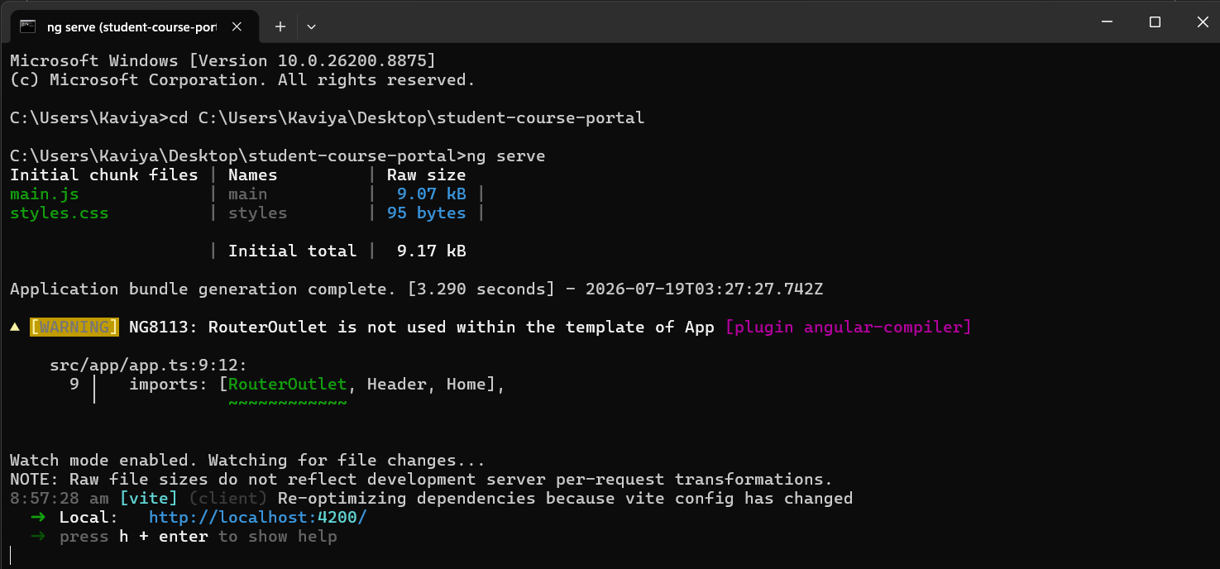
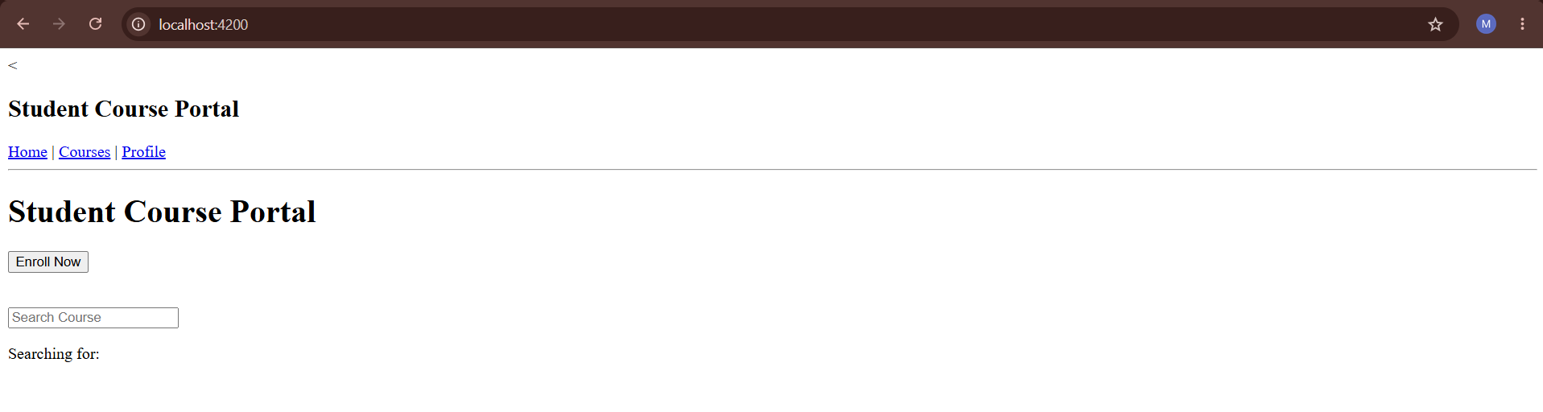
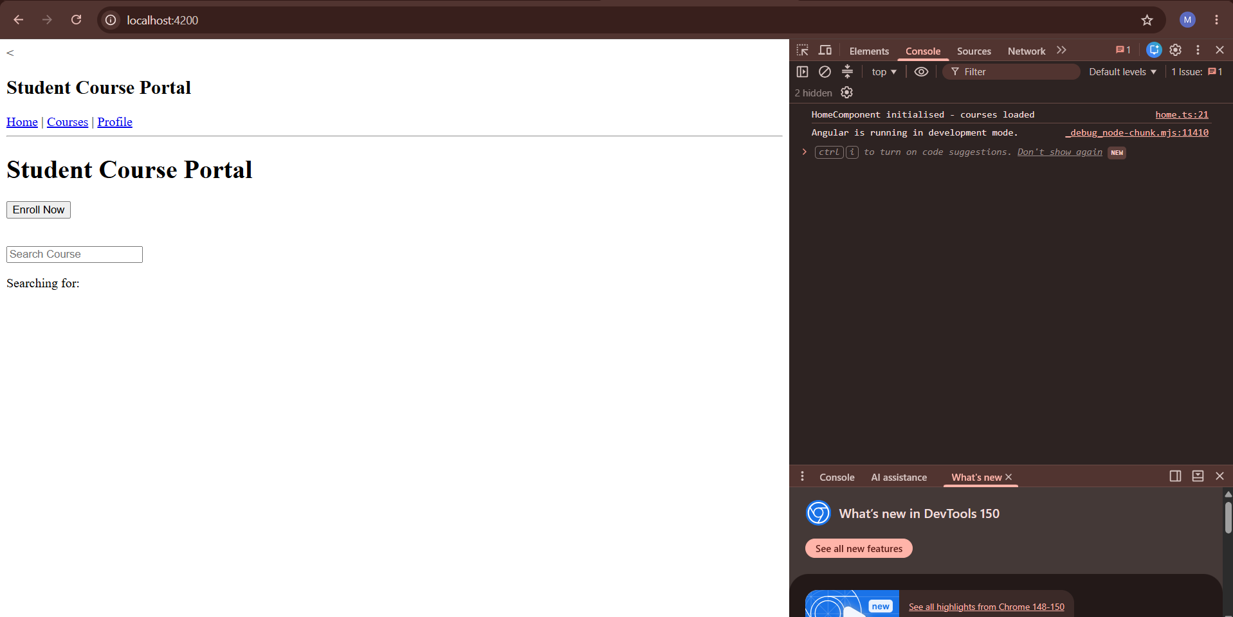
Home.ts
import { Component, OnInit, OnDestroy } from '@angular/core';
import { FormsModule } from '@angular/forms';

@Component({
selector: 'app-home',
imports: [FormsModule],
templateUrl: './home.html',
styleUrl: './home.css',
})
export class Home implements OnInit, OnDestroy {

portalName = 'Student Course Portal';

isPortalActive = true;

message = '';

searchTerm = '';

ngOnInit() {
console.log('HomeComponent initialised - courses loaded');
}

ngOnDestroy() {
console.log('HomeComponent destroyed');
}

onEnrollClick() {
this.message = 'Enrollment opened!';
}

}

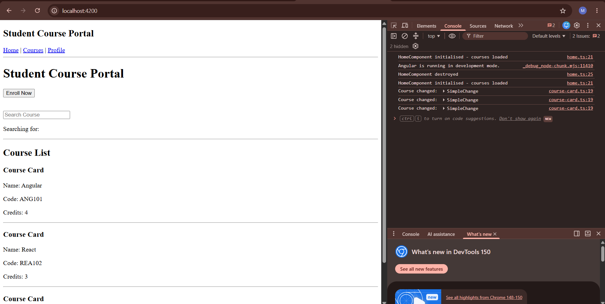
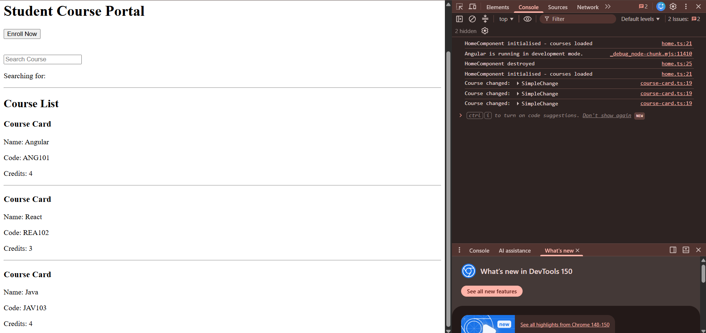
Course list.ts
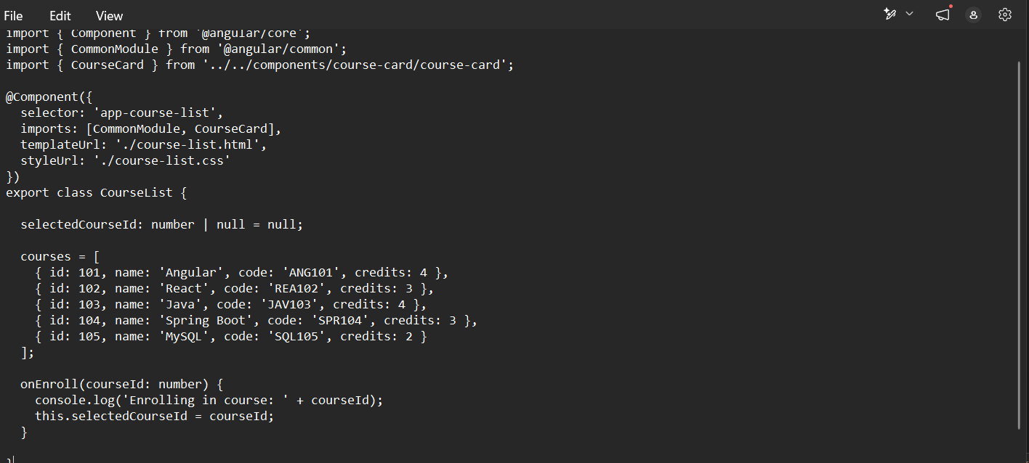
Course card.ts
import {
Component,
Input,
Output,
EventEmitter,
OnChanges,
SimpleChanges
} from '@angular/core';

@Component({
selector: 'app-course-card',
imports: [],
templateUrl: './course-card.html',
styleUrl: './course-card.css'
})
export class CourseCard implements OnChanges {

@Input() course!: {
id: number;
name: string;
code: string;
credits: number;
};

@Output() enrollRequested = new EventEmitter<number>();

ngOnChanges(changes: SimpleChanges) {
console.log('Course changed:', changes['course']);
}

}

